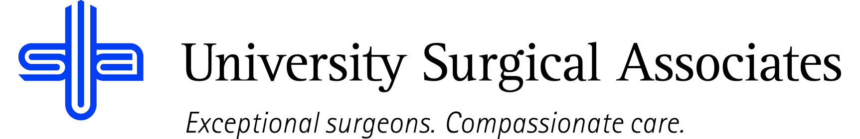

JOB TITLE: COMMUNICATIONS SUPERVISOR
DEPARTMENT: COMMUNICATIONS
REPORTS TO: INTAKE BUSINESS OFFICE MANAGER

JOB SUMMARY:
The Communications Supervisor is responsible for supervising the communications staff, while also acting as a switchboard operator. The Communications Supervisor will use problem solving and troubleshooting abilities to ensure daily functions are maintained within the established standards. They will also be responsible for staffing and training new staff members within the Communications Department.

POSITION ACCOUNTABILITIES:
- Commitment to perform all job responsibilities in accordance with the philosophy and mission statement of USA. Honest, ethical, and professional behavior are conditions of employment.
- Directs and oversees the day-to-day assignment of tasks for the Communications team
- Handles daily problem-solving requests for Communications and cross-functional teams
- Coordinates the training of new team members, and the ongoing training of current staff members
- Ensures appropriate coverage during periods of scheduled and/or unscheduled PTO, as well as regularly scheduled staff meetings
- Manages timesheets for Communications Team
- Prepares performance evaluations for the communication staff and discipline reports, if necessary
- Meets regularly with leadership to discuss and resolve any issues
- Is responsible for Communications Protocols to include: Clarus, Bright Metrics, Call sheets, Vital Interactions, Provider and nurse preference sheets, etc.
- Works with leadership to develop, monitor, and track performance metrics within the Communications team
- Performs duties related to and maintains the knowledge of the electronic registration system as it relates to training.
- Performs all other duties as assigned

PHYSICAL REQUIREMENTS:
The physical requirements listed are representative of those that may be faced by a Communications Supervisor throughout their scope of employment. To conduct this position properly, applicants must be able to complete the following list of physical tasks. Reasonable accommodation will be available for those individuals with disabilities who are not able to complete the following tasks.
- Sitting for prolonged periods of time
- Bending and reaching
- Specific vision abilities required by this job include close vision, distance vision, and ability to adjust focus as needed

QUALIFICATIONS:
- High school diploma or equivalent
- Minimum of 2 years experience in a medical office
- Prefer previous experience in a supervisory role
- Excellent written and verbal communication skills

The above duties are intended to describe the general nature and level of work performed. They are not intended to be an exhaustive list of all responsibilities, duties, and skills required of an employee so classified.

University Surgical Associates is an at will employer. Your employment with University Surgical Associates is for an indefinite period of time and it is subject to termination by you or University Surgical Associates with or without cause, with or without notice, and at any time

Employee Signature: Date:

Supervisor Signature: Date:

