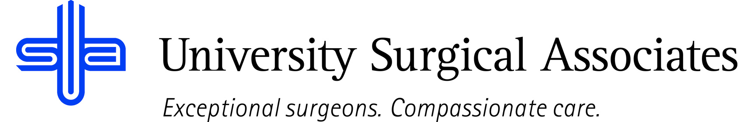

JOB TITLE: HUMAN RESOURCES GENERALIST
DEPARTMENT: HUMAN RESOURCES
REPORTS TO: HUMAN RESOURCES DIRECTOR

JOB SUMMARY:
The HR Generalist is responsible for supporting and executing a wide range of HR functions, including recruitment, employee relations, benefits administration, performance management, compliance and HR policies. This role serves as a key point of contact for employees and managers, ensuring a positive employee experience while maintaining compliance with employment laws and organizational standards.

POSITION ACCOUNTABILITIES:
- Commitment to perform all job responsibilities in accordance with the philosophy and mission statement of USA. Honest, ethical, professional behavior is a condition of employment
- Performs various duties, as assigned
Employee Relations –
- Serve as a trusted resource for employees and managers on HR policies, procedures and best practices
- Adress employee questions, concerns and complaints in a timely and professional manner
- Support conflict resolution and assist with investigations, as needed
Recruitment & Onboarding –
- Assist with full-cycle recruiting, including job postings, screening, interviewing and job offering coordination
- Coordinate onboarding and orientation for new hires to ensure a smooth transition
- Maintain accurate recruitment and hiring documentation
Benefits & Compensation –
- Administer employee benefits programs, including retirement and leave programs
- Assist employees with benefit enrollment, changes and questions
- Support compensation processes such as salary changes, promotions and evaluations
- Assist with payroll process
Performance Management –
- Support electronic performance review process
- Provide guidance to managers on performance improvement plans and disciplinary actions, ad needed
- Maintain performance documentation in HR system
Compliance & Policy Administration –
- Ensure compliance with federal, state and local employment laws and regulations
- Assist in developing, updating and enforcing HR policies and procedures
- Maintain accurate and confidential records
HR Operations & Reporting –
- Maintain HRIS data accuracy and generate HR reports as needed
- Support audits, compliance reporting and HR metrics tracking
- Participate in HR projects and process improvement initiatives
Competencies –
- Professional judgment and ethical conduct
- Attention to detail and organizational skills
- Ability to multitask and prioritize in a fast-paced environment
- Collaborative and adaptable team player with strong customer service mindset

PHYSICAL REQUIREMENTS:
The physical requirements listed are representative of those that may be faced by a HR Generalis throughout their scope of employment. To conduct this position properly, applicants must be able to complete the following list of physical tasks. Reasonable accommodation will be available for those individuals with disabilities, and are not able to complete the following tasks.
- Sitting for prolonged periods of time
- Light lifting, possibly weights up to 30 pounds
- Bending and reaching
- Specific vision abilities required by this job include close vision, distance vision, and ability to adjust focus as needed

REQUIRED QUALIFICATIONS:
- Bachelor’s degree in Human Resources, Business Administration or related field
- 2-5 years of experience in Human Resources role, preferably as a generalist
- Knowledge of employment laws and HR best practices with ability to handle confidential information with discretion
- Strong interpersonal, communication and problem-solving skills with proficiency in HRIS systems and MS Office
PREFERRED QUALIFICIATIONS:
- HR Certification (SHRM-CP or similar)
- Experience supporting a diverse workforce; healthcare experience, preferred
- Familiarity with payroll, benefits systems and employee engagement initiatives

The above duties are intended to describe the general nature and level of work performed. They are not intended to be an exhaustive list of all responsibilities, duties, and skills required of an employee so classified.

University Surgical Associates is an at will employer. Your employment with University Surgical Associates is for an indefinite period of time and it is subject to termination by you or University Surgical Associates with or without cause, with or without notice, and at any time

Employee Signature: Date:

Supervisor Signature: Date:

