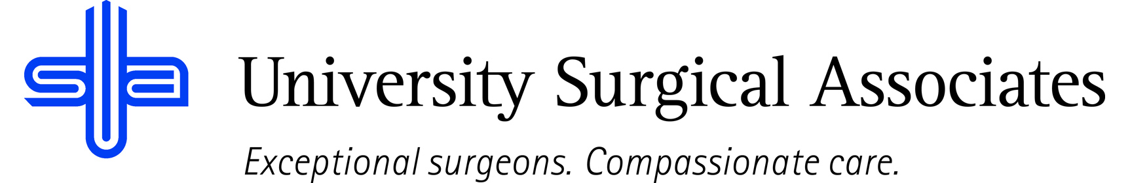

JOB TITLE: GENERAL SURGERY/ACUTE CARE NURSE PRACTITIONER
DEPARTMENT: CLINICAL OPERATIONS
REPORTS TO: ATTENDING GENERAL SURGEON/SURGICAL SERVICES DIRECTOR

JOB SUMMARY:
The General Surgery/Acute Care Nurse Practitioner provides advanced clinical support to the surgical team through comprehensive hospital rounding, management of new consults, patient triage, and coordination of care. This role ensures efficient workflow for the surgeon and contributes to high-quality, patient-centered care.

The NP will round on inpatients Monday through Thursday, manage consults and triage needs throughout the day, and support clinical decision-making for the surgical service. On Fridays, the NP will conduct morning hospital rounds, facilitate patient and provider calls throughout the day, and hold dedicated office hours in the afternoon.

POSITION ACCOUNTABILITIES:
Inpatient:
- Perform daily hospital rounds on post-operative, acute care, and consult patients.
- Conduct focused assessments, document daily progress notes, and update treatment plans.
- Manage new inpatient consults, perform initial assessments, and communicate findings to the surgeon.
- Triage and respond to urgent clinical needs in collaboration with the surgical team.
- Order and interpret diagnostic tests, imaging, and laboratory studies.
- Coordinate care with nursing staff, case management, therapy teams, and other specialists.
- Prepare patients for surgery as appropriate, including obtaining histories, consents, and pre-operative evaluations.
- Provide post-operative education, discharge planning, and follow-up instructions.

Outpatient:
- Perform morning inpatient rounds and manage any new consults.
- Provide telephone-based triage and clinical support throughout the day.
- Serve as the primary point of contact for patient questions, care coordination, and clinical inquiries.
- Hold office hours in the afternoon for outpatient follow-up visits, wound checks, post-operative evaluations, and new patient assessments.
- Assist the surgeon with in-office procedures as needed.

General Duties:
- Maintain comprehensive and timely medical record documentation.
- Participate in multidisciplinary rounds, handoffs, and quality initiatives.
- Ensure evidence-based, safe, and efficient patient care.
- Support workflow optimization for the attending surgeon and surgical team.
- Adhere to hospital policies, clinical guidelines, and regulatory standards.
- Commitment to perform all job responsibilities in accordance with the philosophy and mission statement of USA. Honest, ethical, professional behavior is a condition of employment
- Perform all other duties as assigned

PHYSICAL REQUIREMENTS:
The physical requirements listed are representative of those that may be faced by an Office Based Nurse Practitioner throughout their scope of employment. To conduct this position properly, applicants must be able to complete the following list of physical tasks. Reasonable accommodation will be available for those individuals with disabilities, and are not able to complete the following tasks.
- Sitting, standing, walking for prolonged periods of time
- Bending and reaching
- Manual dexterity
- Specific vision abilities required by this job include close vision, distance vision, and ability to adjust focus as needed
- Lifting weights possibly up to 50 pounds

QUALIFICATIONS:
- Master’s or Doctorate degree in Nursing from an accredited Nurse Practitioner program.
- Active Nurse Practitioner license and certification (ACNP, FNP, or AGACNP accepted depending on state/scope).
- Experience in general surgery, acute care, or hospital-based medicine preferred.
- Strong clinical assessment, communication, and decision-making skills.
- Ability to work independently while maintaining close collaboration with the surgical team.
- Comfortable managing urgent clinical situations in a hospital setting.

The above duties are intended to describe the general nature and level of work performed. They are not intended to be an exhaustive list of all responsibilities, duties, and skills required of an employee so classified.

University Surgical Associates is an at will employer. Your employment with University Surgical Associates is for an indefinite period of time and it is subject to termination by you or University Surgical Associates with or without cause, with or without notice, and at any time

Employee Signature: Date:

Supervisor Signature: Date:

