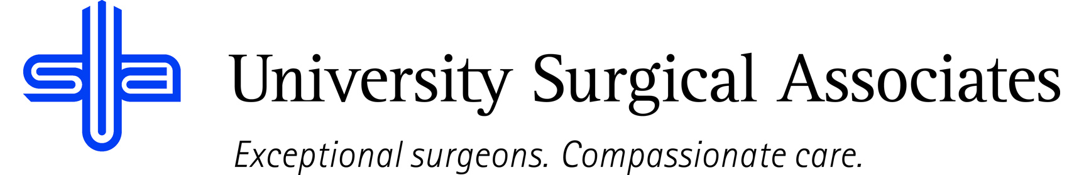

JOB TITLE: EXECUTIVE ASSISTANT
DEPARTMENT: ADMINISTRATION
REPORTS TO: CHIEF EXECUTIVE OFFICER and CHIEF OPERATING OFFICER

JOB SUMMARY:
The Executive Assistant is responsible for providing clerical support for the CEO and COO by scheduling meetings and appointments, organization and execution of contracts and leases, general administrative duties and assistance with special projects.

POSITION ACCOUNTABILITIES:
- Commitment to perform all job responsibilities in accordance with the philosophy and mission statement of USA. Honest, ethical, professional behavior is a condition of employment.
- Maintaining meeting schedule for CEO and COO and prepares required documents for, reminders for and access to meetings through Outlook, Zoom, Teams, etc.
- Maintenance of minutes from faculty meetings, board meetings, etc.
- Maintenance of various contracts – i.e., physician contracts, lease agreements, etc. Also responsible for storage of original documents, tracking expiration dates and scanning into an electronic file system
- Handling of lawsuits – acceptance of the suits, communication and coordination with attorneys regarding scheduling physician interviews/statements, making sure the arrangements are made in advance and blocking/scheduling physician’s time
- Screens, responds and prioritizes communications (phone, voicemail, email, etc.) with CEO and COO
- Provides clerical support for the CEO and COO, as needed. To include: typing memos/letters, distributing the memos/letters, copying, faxing, pulling files, filing, etc.
- Provides assistance with projects, as needed
- Maintain provider onboarding and offboarding process
- Performs other duties as assigned

PHYSICAL REQUIREMENTS:
The physical requirements listed are representative of those that may be faced by an Executive Assistant throughout their scope of employment. To conduct this position properly, applicants must be able to complete the following list of physical tasks. Reasonable accommodation will be available for those individuals with disabilities, and are not able to complete the following tasks.
- Sitting or standing for prolonged periods of time
- Bending and reaching
- Data entry/typing for prolonged periods of time
- Able to lift weights possibly up to 40 pounds
- Specific vision abilities required by this job include close vision, distance vision, and ability to adjust focus as needed

QUALIFICATIONS:
- High school diploma or equivalent required
- Associate degree or bachelor’s degree in related field strongly preferred
- Excellent verbal and written communication skills including grammar, composition, etc. with a strong emphasis in discretion and confidentiality
- Previous experience in a medical office setting strongly preferred
- Exceptional computer operating abilities and overall knowledge
- Proficient in use of Microsoft Office applications including Word, Excel, Outlook, etc.

The above duties are intended to describe the general nature and level of work performed. They are not intended to be an exhaustive list of all responsibilities, duties, and skills required of an employee so classified.

University Surgical Associates is an at will employer. Your employment with University Surgical Associates is for an indefinite period of time and it is subject to termination by you or University Surgical Associates with or without cause, with or without notice, and at any time

Employee Signature: Date:

Supervisor Signature: Date:

