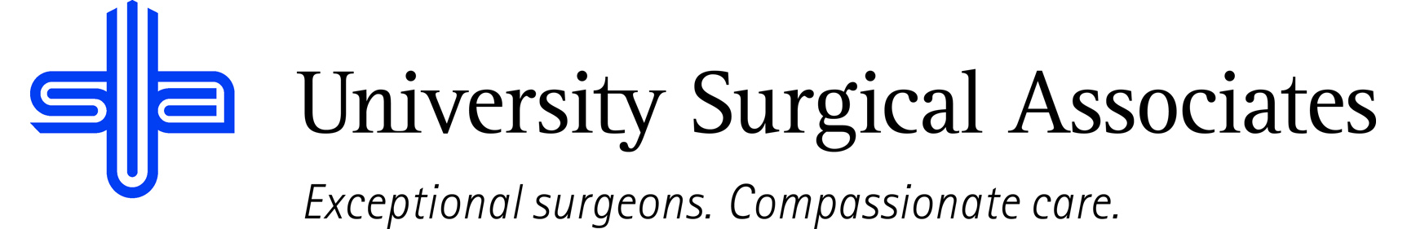

JOB TITLE: PROSTHETIC ASSISTANT
DEPARTMENT: PROSTHETICS
REPORTS TO: PROSTHETICS MANAGER

JOB SUMMARY:
The Certified Prosthetic Assistant, under the supervision of the Prosthetics Manager and the Prosthetist, is responsible for performing prosthetic procedures and related tasks in the course of patient care. The supervising Prosthetist is responsible for the initial evaluation and formulation of the treatment plan; however, the Certified Prosthetic Assistant may be responsible for fabricating, repairing, and maintaining prostheses. The Certified Prosthetic Assistant is obligated to support the patient and the integrity of the profession.
POSITION ACCOUNTABILITIES:
- Commitment to perform all job responsibilities in accordance with the philosophy and mission statement of USA. Honest, ethical, professional behavior is a condition of employment
- Assists with patient evaluations
- Participates in the assessment of patients with impairment of movement or musculoskeletal abnormalities that would impede their ability to participate in their daily life activities in order to determine a functional intervention
- Participates in the implementation of an established prosthetic treatment plan in tandem with the supervising Prosthetist
- Performs casting under the supervision of the Prosthetist
- Performs diagnostic fittings, structural evaluation, assessment of intervention for appropriate outcomes, gait training, functional training, and patient education/instruction
- Performs fabrication/repair of prostheses under the Prosthetist’s supervision
- Performs modifications of prostheses
- Evaluates patients in follow-up utilizing a follow-up treatment plan that ensures successful prosthetic outcomes, patient health, and quality of life. This would include documentation of functional changes, formulation of modifications, reassessment of patient expectations and treatment objectives, and confirmation of patient education and instruction. Notify appropriate personnel of problems or issues as needed
- Complies with the practice management plans to develop and document policies and procedures to ensure patient well being
- Assembles prosthesis for fittings and deliveries
- Works with the outside fabrication staff as needed regarding modifications, scheduling, and delivery of prostheses on a timely basis
- Completion of continuing education requirements in order to maintain certification and enhance professional prosthetic knowledge
- Assist with ordering and inventory
- Chart dictation as needed
- Performs all other duties as assigned

PHYSICAL REQUIREMENTS:
The physical requirements listed are representative of those that may be faced by a Certified Prosthetic Assistant throughout their scope of employment. To conduct this position properly, applicants must be able to complete the following list of physical tasks. Reasonable accommodation will be available for those individuals with disabilities, and are not able to complete the following tasks.
- Lifting up to 70 pounds (at times, more than 70 pounds)
- Standing, bending, reaching, crouching, kneeling or sitting on floor to assist with modifications to prosthesis for prolonged periods of time (at times, up to 60 minutes or more)
- Sitting, standing, walking for brief periods of time
- Manual dexterity
- Specific vision abilities including: close vision, distance vision, and ability to adjust focus

QUALIFICATIONS:
- High school diploma or equivalent
- Previous experience as a prosthetic assistant preferred
- Certification in Prosthetic Assisting preferred, but not required
- Good written and verbal communication skills

The above duties are intended to describe the general nature and level of work performed. They are not intended to be an exhaustive list of all responsibilities, duties, and skills required of an employee so classified.

University Surgical Associates is an at will employer. Your employment with University Surgical Associates is for an indefinite period of time and it is subject to termination by you or University Surgical Associates with or without cause, with or without notice, and at any time

Employee Signature: Date:

Supervisor Signature: Date:

