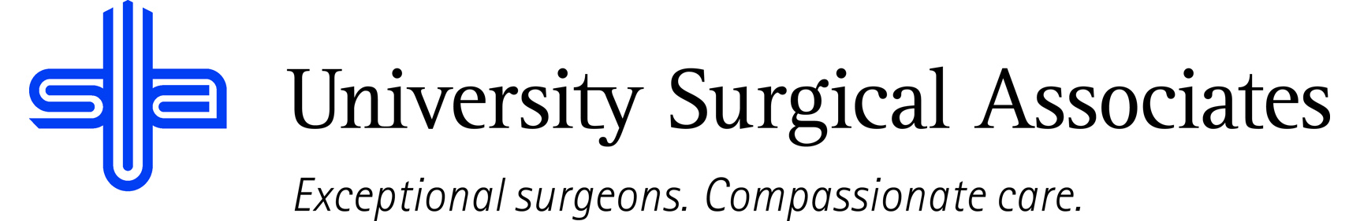

JOB TITLE: ACCOUNTS RECEIVABLE INSURANCE SPECIALIST
DEPARTMENT: BUSINESS OFFICE
REPORTS TO: BUSINESS OFFICE MANAGER

JOB SUMMARY:
The A/R Insurance Specialist Level 2 is responsible for coordinating all activities related to accounts receivable. They are to ensure that payments are posted in a timely manner to their appropriate account. The Level 2 A/R Insurance Specialist is more responsible for the team surrounding them. They should have more years of experience than a Level 1, and they should have the ability to assist other members in need of assistance. They should be able to troubleshoot any problems that arise while reviewing patient’s accounts or with reimbursement from insurance providers. They should also have the ability to notice any unordinary trends that may occur throughout the claims process.

POSITION ACCOUNTABILITIES:
- Commitment to perform all job responsibilities in accordance with the philosophy and mission statement of USA. Honest, ethical, professional behavior is a condition of employment
- Reviews and analyzes patient’s accounts for write-offs or other actions and submits refund requests to the proper personnel
- Evaluates account receivables on a monthly basis to ensure that all accounts are worked in a timely and accurate manner
- Notifies manager of any trends and/or issues that are identified throughout the process
- Posts charges, payments, and adjustments when related to account corrections
- Responsible for handling/reviewing all phone and mail correspondence related to insurance and patient accounts. Works insurance denials from mail and online websites
- Files both primary and secondary claims; sending operative report if necessary
- Researches any questions from patients, third-party payers, etc. on all USA accounts
- Maintains a working knowledge of insurance to achieve objective of furnishing prompt, accurate information to the correct party to expedite payment of maximum allowable benefits
- Maintains a positive working relationship with provider representatives to ensure correct and timely payment
- Handles outgoing mail daily through use of postage machine
- Performs all other duties as assigned

PHYSICAL REQUIREMENTS:
The physical requirements listed are representative of those that may be faced by an ARIS (Level II) throughout their scope of employment. To conduct this position properly, applicants must be able to complete the following list of physical tasks. Reasonable accommodation will be available for those individuals with disabilities, and are not able to complete the following tasks.
- Sitting or standing for prolonged periods of time
- Bending and reaching
- Specific vision abilities required by this job include close vision, distance vision, and ability to adjust focus as needed

QUALIFICATIONS:
- Previous medical insurance processing experience
- Excellent typing and computer operating skills
- Must have a strong understanding of medical terminology
- Two or more years or experience in billing and insurance preferred

The above duties are intended to describe the general nature and level of work performed. They are not intended to be an exhaustive list of all responsibilities, duties, and skills required of an employee so classified.

University Surgical Associates is an at will employer. Your employment with University Surgical Associates is for an indefinite period of time and it is subject to termination by you or University Surgical Associates with or without cause, with or without notice, and at any time

Employee Signature: Date:

Supervisor Signature: Date:

